**IMPLEMENTATION OF SOME FEATURES OF GOOGLE MAPS USING DIJKSTRA’S ALGORITHM AND DYNAMIC PRORAMMING**

Abstract

This project gives us an insight into how some of the Google Map features work and what keeping in mind are goods delivered to customers. Is the order random? If it isn’t, what it is and how to find this order. Very much thought has been given to optimize the algorithms wherever possible.

Features Implemented:

1. Find shortest distance to any place

2. Option to include petrol pump in the journey for refueling.

3. Autocompletion of search.

4. Different modes of travelling (Car, Motorcycle, Walking)

5. Time taken for the journey.

6. Total cost of the journey.

7. Find petrol pumps / hotels near the user’s location: prints the petrol pumps / hotels in order of their increasing distance from user’s location and the shortest path to reach them along with the distance.

8. Find shortest distance to visit multiple places on a single trip and them come back to user’s original location: Made especially for delivery men in order to find out the most efficient (cost and time saving) path to travel to multiple places and deliver goods to customers . Find out the order in which goods will be delivered to customers. We can also prefer some customers for their goods to be delivered first. (for ex : if they are a prime member). The time complexity of this algorithm has been drastically reduced from X*X!* ElogV to

X* ElogV using dynamic programming.

Map used for demonstrating various features of program :

Here P1, P2 , P3 are petrol pumps and H1, H2, H3 are hotels.

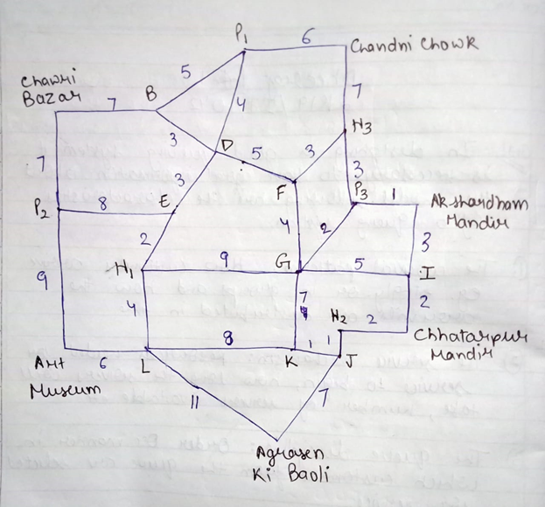

Working and Analysis:

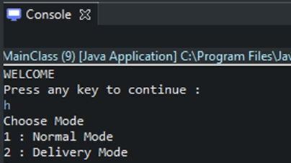

On choosing normal mode , it gives us 3 options :

1. Find route to a place

2. Find petrol pump near me

3. Find hotel near me

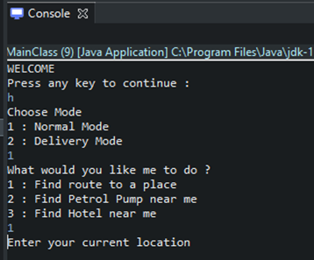

For now we will choose option 1.

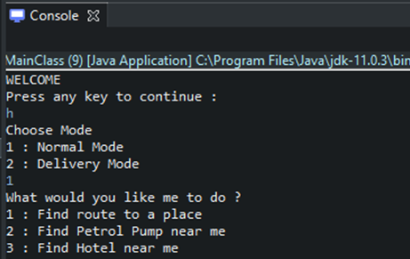

Now it asks the user’s current location.

Let’s say Chawri Bazar.

On typing c , it autocompletes the search and shows us names of 3 places starting with ‘c’

The search autocompletion feature is implemented using trie data structure.

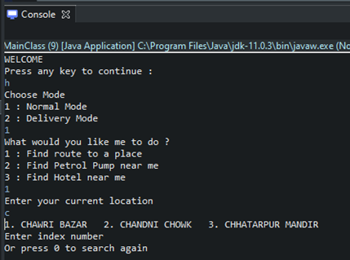

If we type any wrong index number it will ask us to try again .

Entering index 1 on the console , it asks for the user’s destination .

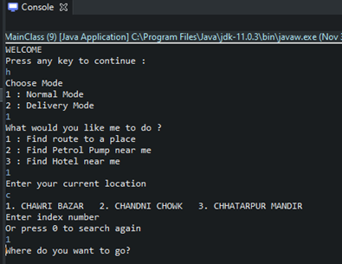

Now it asks how the user wants to go to the destination (Car / Motorcycle / Walk).

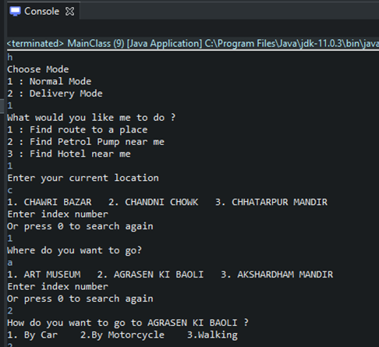

Now it asks if the user wants a petrol pump in the route. On typing ‘yes’ , it shows a path with a petrol pump.

Each of the different modes have different average speeds and mileage (in case of car/ motorcycle). Price of the petrol is Rs 80 per litre.

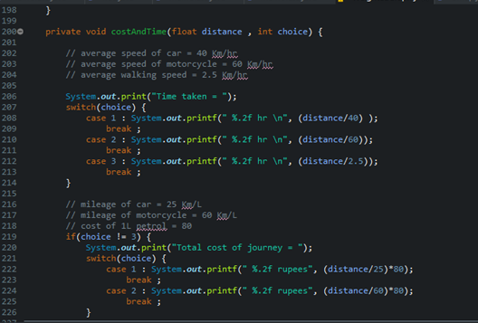

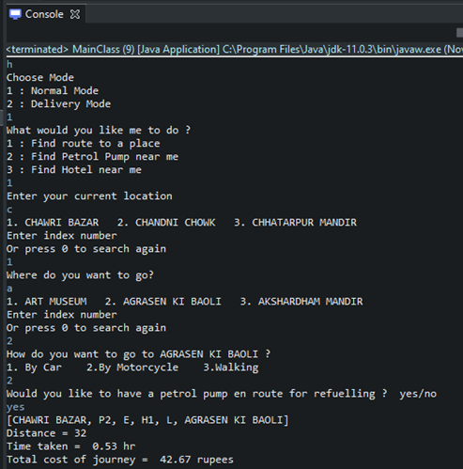

The distance and choice is fed into the CostAndTime function which then prints the time and cost of the journey according to formula.

If a user doesn’t want a petrol pump in the route , he can type ‘no’ and the program will display a route with no petrol pump .

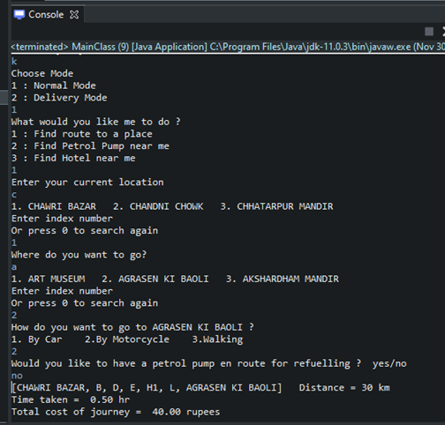

In the next feature, the user can find petrol pump / hotels near his location and the results are printed in ascending order wrt how far it is from the user’s location . The working here is simple, it finds out the shortest path to each of the petrol pump/ hotel using Dijkstra’s Algorithm.

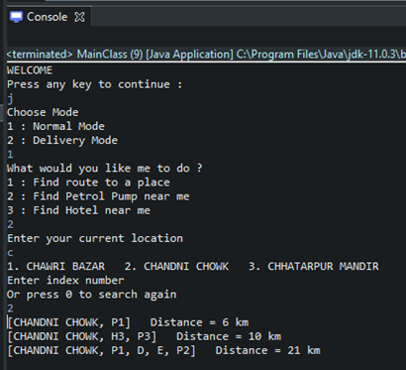

Delivery Mode: In this mode it asks for the user’s location and how many places it wants to visit. It then prints all the possible orders in which those places can be visited and prints the respective full path.

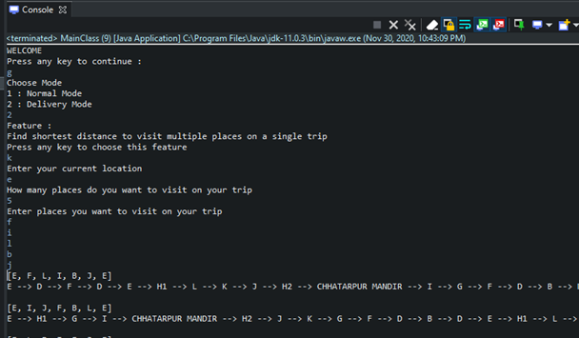

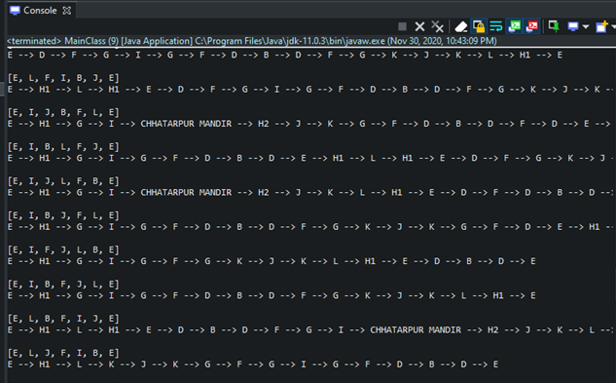

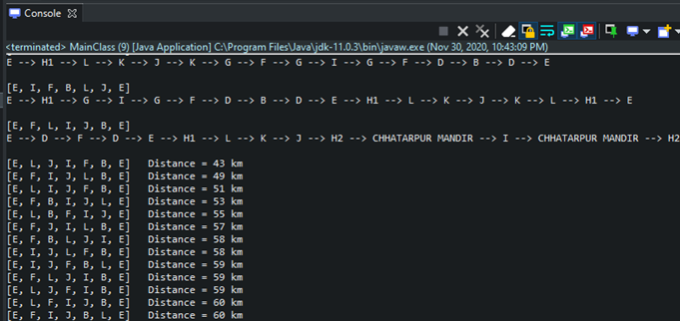

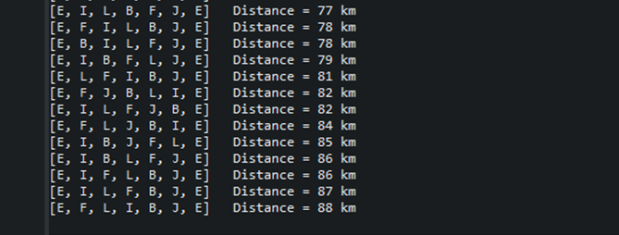

The result is interesting . The longest path visiting of the required places is 88 while the shortest one is 43. Thus companies can save loads of money using this feature.

Where it is used?

The normal mode in this program has similar features to those in Google Maps app such as ‘Explore this area’. The feature of including a petrol pump or hotel in the journey is very similar to adding stops in the journey in Google Maps app. The delivery mode used here finds its use majorly in companies such as Flipkart , Amazon , Zomato, Ola , Uber etc.

Advantages of Delivery Mode :

Delivery Mode is especially useful for delivery men in order to find out the most efficient (cost and time saving) path to travel to multiple places and deliver goods to customers . We can find out the order in which goods will be delivered to customers. We can also prefer some customers for their goods to be delivered first. (for ex : if they are a prime member).

Future Improvements :

We can try to further implement a ‘Left – Right – Go Straight ‘ feature . It will basically tell us in which direction the user should move next.